PTA
PARENT-TEACHER MEETING
2024-25

A Parent-Teacher Meeting (PTM) was conducted on November 23,2024 at St. Bede’s College. The purpose of the meeting was to foster better communication between parents and faculty, discuss students’ academic progress, and address any concerns regarding their overall development. This initiative aimed to strengthen the collaborative relationship between parents and the college. Parents were given the opportunity to meet their wards’ respective teachers to discuss their performance, attendance, and behaviour. Teachers highlighted strengths and suggested areas for improvement. Parents expressed satisfaction with the academic environment and faculty efforts. The Parent-Teacher Meeting was a constructive platform that strengthened the partnership between the college and parents. It provided valuable insights into students' needs and fostered collaborative efforts toward their holistic development.

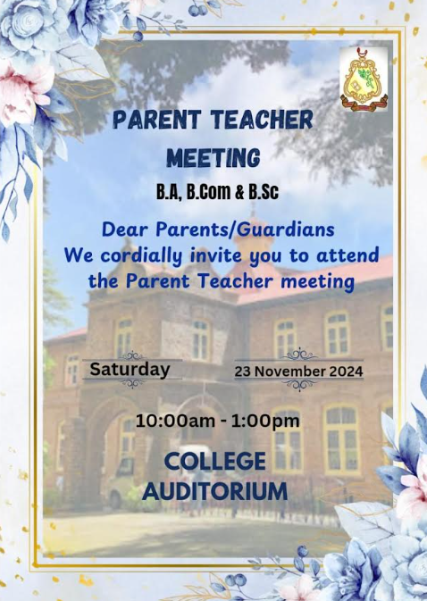
Brochure
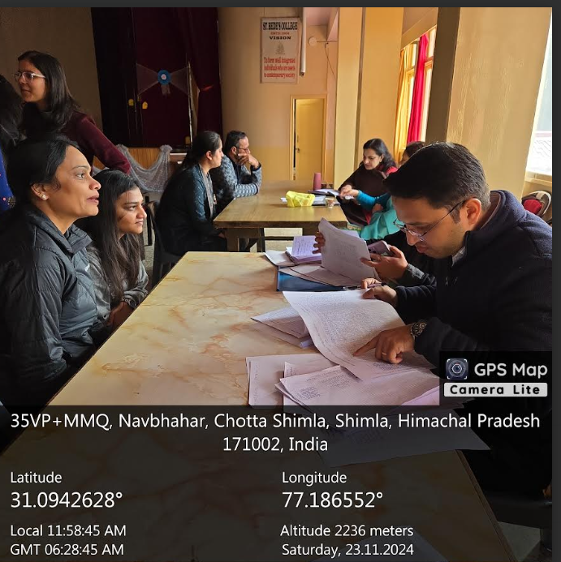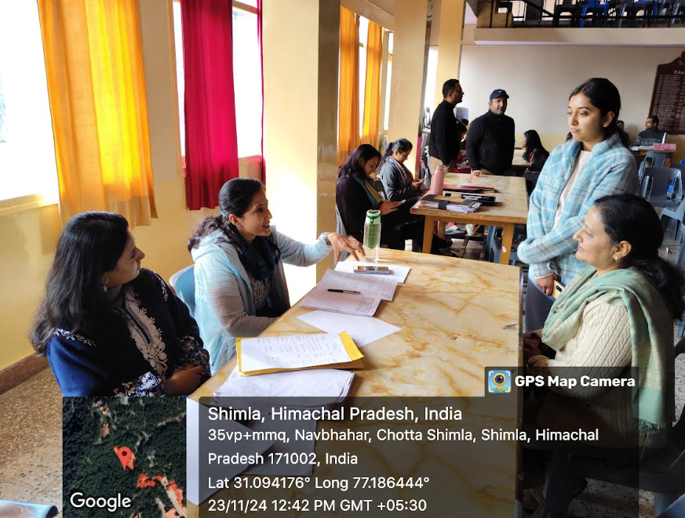
Glimpses of the Parent Teacher Meeting

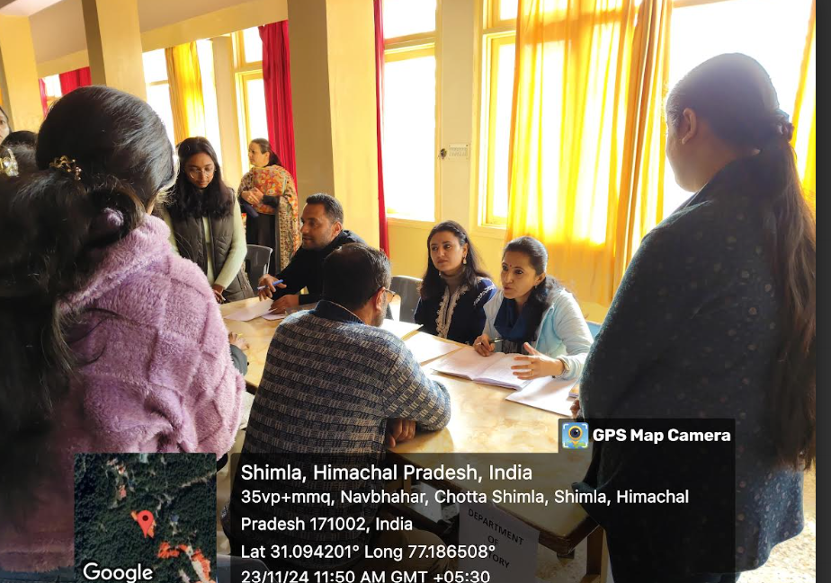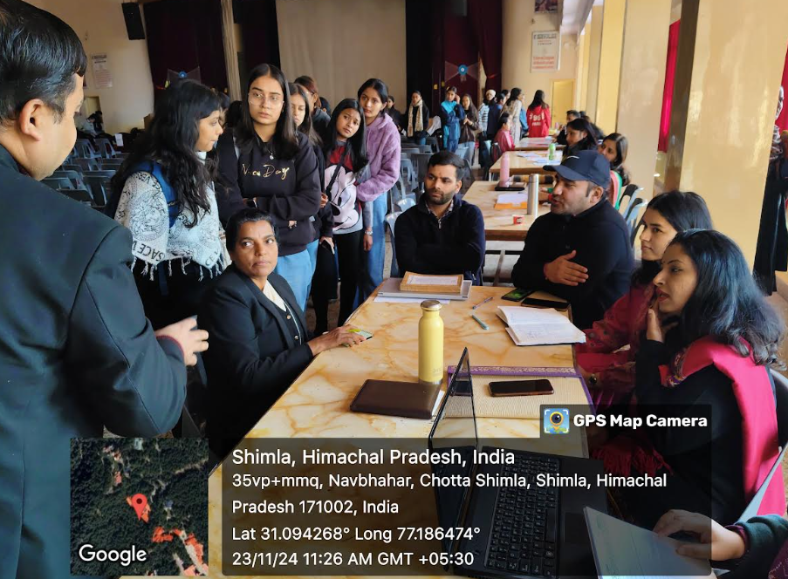

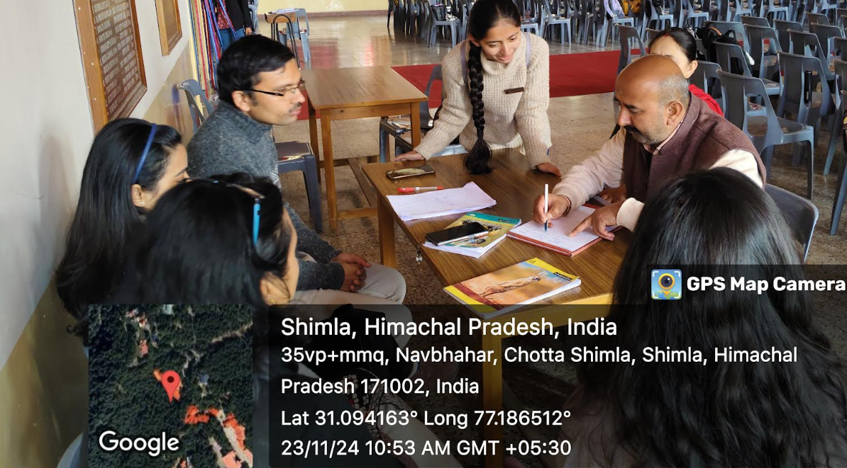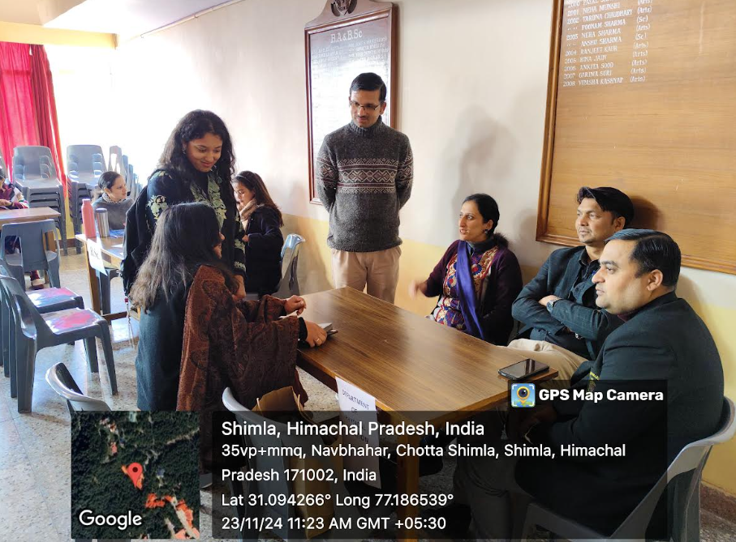
Glimpses of the Parent Teacher Meeting

